SMC Terms of Reference

- Purpose
  - Primary objective
The role of SMC is to provide advice to NHS Boards across Scotland about the status of newly licensed medicines and new indications for established products.
  - Aims
SMC aims to ensure that medicines which offer benefits to patients and value for money are accepted for routine use as quickly as possible.

  - Statutory responsibilities
Healthcare Improvement Scotland (HIS) has specified functions, under the Public Services Reform (Scotland) Act, 2010, for the evaluation and provision of advice to the health service on the clinical and cost effectiveness of new and existing health technologies including drugs (hereafter described as medicines). SMC provides this key function for medicines.

- Function
SMC has two primary functions:

- To provide early advice to NHS Boards and their Area Drug and Therapeutics Committees (ADTCs) about the status of newly licensed medicines as soon as practical after the medicine is available for prescribing, on a “Once for Scotland” basis. SMC assesses the clinical and cost-effectiveness of new treatments by appraising submissions provided by pharmaceutical companies on the health benefits of a medicine and justification of its price. SMC takes into account the views of clinical experts as well as evidence submitted by patient group partners. SMC’s remit covers prescription-only medicines (POMs) and excludes some types of medicine such as vaccines, generics and blood products.

- To improve financial and service planning within NHS Boards, an annual ‘Forward Look’ report is sent in strict confidence to key Health Board personnel to provide early intelligence on new medicines in development (horizon scanning).

- Membership

SMC Committee
The SMC Committee is the decision-making body and is made up of clinicians and senior managers from across NHSScotland, public partners, and representatives of the pharmaceutical industry.

SMC Committee was set up as a consortium of stakeholders from ADTCs and representation is derived from these ADTCs.

SMC Committee composition:
Three public partner representatives.
Three pharmaceutical industry members; recruitment is facilitated through the Association of British Pharmaceutical Industry (ABPI).
Up to two Health Economists who are recruited via academic channels.
There are up to two Directors of Finance and up to two Chief Executive Officers (CEOs) of health boards.
The remainder of the SMC committee is comprised of representatives from ADTCs from a range of health boards which include nurses, allied health professionals (AHP), pharmacists and doctors.

One ABPI member and two Scottish Government staff members from the Medicines and Policy Team are in attendance as Committee Observers.

New Drugs Committee (NDC)
The New Drugs Committee (NDC) is a sub-committee of SMC Committee, tasked with the initial assessment of the clinical and health economic evidence in the company submissions. Membership of NDC is also based on expressions of interest received from ADTCs. As with SMC committee membership, two representatives from pharmaceutical companies are part of NDC, again with their nominations facilitated by ABPI and one Health Economist who is recruited via academic channels.

SMC Team
Both SMC and NDC Committees are supported by a core SMC team staff, including pharmacists, health economists, health service researchers, public involvement professionals and administration support, based in the Evidence & Digital Directorate within Healthcare Improvement Scotland (HIS).

All members of SMC Committee and NDC must abide by the HIS Code of Conduct.

SMC / NDC Chair and Vice Chairs
The SMC / NDC Chair and Vice Chairs form the membership of the SMC Executive, alongside senior members of SMC staff.

SMC Executive
The remit of the SMC Executive team is to lead the development and ratification of SMC strategy and policy and to support SMC staff in the implementation of methodology and process.

A current list of membership is accessible at:

https://www.scottishmedicines.org.uk/about-us/who-we-are/

  - Organogram

SMC Chair

NDC Chair/ SMC Vice Chair
SMC Vice Chair

Clinical Advisor

NDC Vice Co-Chair
NDC Vice Co-Chair

  - Role of the SMC & NDC Chair and Vice-Chair(s)
Detailed job descriptions for the Chair and Vice-Chair(s) are set out in Appendix 1 and 2, but there are some general requirements as follows:
- The Chair is responsible for the direction, conduct, progress and completion of SMC business, both during meetings and between the meetings, and in this task is supported by SMC Senior Management Team and the SMC Executive.
- The Chair will approve the draft minutes, which are prepared by the SMC secretariat.
- The Chair ensures that declaration of interests forms from all SMC members are scrutinised and any issue of concern discussed with the individual concerned and/or the SMC Executive. The Chair must also ensure that at the beginning of each meeting members are asked to declare any additional recently acquired interests, and is expected to exercise judgement in the conduct of Council business in the event of any potential conflicts of interest.
- The Vice-Chair(s) will chair meetings of SMC / NDC if the Chair is unable to attend, and will substitute for the Chair at other meetings where appropriate.
- The Chair and Vice-Chair(s) will work with SMC Executive and the SMC Senior Management Team to facilitate the collective achievement of its terms of reference.

  - Role of members
The New Drugs Committee (NDC) is tasked with the initial assessment of the clinical and health economic evidence in the company submissions. Members of the SMC committee consider a broad range of evidence in order to decide which medicines should be accepted for use by NHSScotland. The SMC Committee has delegated accountability for the advice published.

The SMC and NDC Committee are responsible for adhering to SMC methodology and processes in the context of decision making.

NHS Boards and their Area Drug and Therapeutic Committees are responsible for implementation of the advice set out in SMC publications.

All members of SMC Committee and NDC must abide by the HIS Code of Conduct

  - Membership arrangements

Upon receipt of completed nomination forms, the SMC Executive team identifies replacements for those leaving the committee to ensure broad representation from Health Boards. Clinician members are usually doctors, pharmacists and other non-medical prescribers.

New members are formally invited to join the Committee by the Chair and the term of membership is a period of three years, but may be extended, by mutual agreement between the committee member, their employer and the SMC Executive.

  - Voting rights
All SMC members (as noted in the current membership link on the SMC website) are eligible to vote. Decisions will be taken by a simple majority of the voting members. Voting is undertaken formally and if there is a split decision, the Chair has the casting vote.

See Appendix 3 for voting process.

- Chair and Vice-Chair recruitment
The appointment of SMC and NDC Chairs is via a formal, open recruitment process. These posts are offered on the basis of secondment from an NHS Board for a period of three years. There are also three Co-Vice Chairs (one for SMC, and two for NDC), and a Clinical Adviser, who are also appointed via a formal, open recruitment process.

Recruitment to these positions is as per HIS Recruitment policies and procedures.

- Meetings
  - Frequency
The SMC committee usually meets in public on the first Tuesday of each month and the NDC usually meets on the last Tuesday of each month. Meetings are held at a place (in person or virtual) and time as determined by the SMC Executive.

Members should aim to attend all scheduled meetings but are expected to attend at least eight meetings per year.

  - Agenda
Submissions are scheduled for assessment at specific meetings and added to the agenda by the SMC secretariat and form the bulk of the agenda at both SMC and NDC meetings. An agenda and supporting meeting papers are uploaded to a secure website 10 days in advance of the meeting. Additional items for discussion under AOCB may be requested via the Chair.

  - Quorum
The quorum for both SMC and NDC Committees is one third of voting membership of each respectively. There is no stipulation about the composition of voting members that must be present.
  - Declaration of interests
Declarations of interest are collected annually in line with the Evidence Directorate, Declarations of interest definitions and policies for handling of interests at meetings.
Declarations of interest are also recorded at each meeting prior to discussion for each medicine at the meeting.

  - Minutes
Meetings are facilitated by administrative members of the SMC secretariat. Minutes of the proceedings of SMC and NDC meetings are issued to Committee members with paperwork 10 days in advance of the next meeting. The minutes of the SMC meeting are published on the SMC website 4 weeks following the meeting.
- Governance and lines of accountability
Responsibility for the provision of independent advice to NHS Scotland based on health technology assessment (clinical and cost effectiveness) of new medicines is delegated to the SMC committee. SMC is part of the Evidence Directorate of Healthcare Improvement Scotland.
The governance reporting route, for SMC committee, is through the Quality and Performance Committee to the HIS Board.
Healthcare Improvement Scotland, through the Director of Evidence & Digital and the SMC Chief Pharmaceutical Adviser, is responsible for SMC operations, including methodology and adequate resources to maintain the integrity of the SMC business and process. The strategic direction and annual work plan of SMC will be set by the SMC Chair and SMC Chief Pharmaceutical Adviser, in collaboration with the Director of Evidence & Digital and Executive Team at Healthcare Improvement Scotland.
Quarterly meetings take place with the Medicines and Pharmacy Team within the Chief Medical Officer Directorate, Scottish Government.
Terms of Reference will be reviewed every two years or earlier if required.
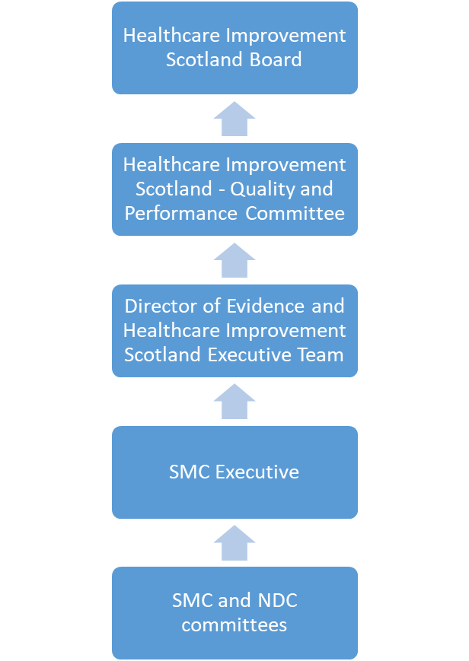

Appendix 1: SMC and NDC Chair Role descriptors

Appendix 2: SMC and NDC Vice Chair Role Descriptors

Appendix 3: SMC Clinical Adviser Role Descriptor

Appendix 4: SMC Voting procedure

